Total-27
- what is float property how to use it?[1M]
- which are the formatting tag in html?[1M]
- Applay extenal css on input text box to set border color,bg color and focus[1M]
- Print the sum of all even element from array using JS[1M]
- Create form which contain input box with email,password,dropdownlist,radiobutton,checkbox,submit,reset button etc.[1M]
- format above form using bootstrap.[1M]
- List down all String functions with example.[1M]
- Create array of object subject which contain [id, name , subtopic]and subtopic conatain[topicid,topicname][2M]
- write JS program which revers a String.[1M]
- write down the ways to print output in JS[1M]
- what is Json?why use json.[1M]
- What is Difference between == and === ? [1M]
- Write a javascript code to accept data in below form and on click event display data in textarea? [2M]

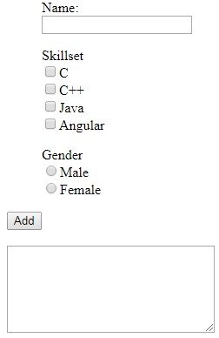
- write code to create person object and array using Json[1M]
- How to crate arrow function using parameter[1M]
- write example of mediaQuery[1M]

- write a code for create following table.[2M]
StudentName | Result
StudentName | HTMl | CSS | Java
Sagar | 43 | 23 | 56

- print pattren[1M]

*
* *
* * *
- what is local storage and session Storage write code for local Storage[2M]
- What is JSON and Explain JSON.stringify() and JSON.parse()? [1M]
- Difference between var and let?[1M]
- Write a javascript code to accept data in 2 textboxes and on click event validate following [2M]
- Check whether text boxes are empty
- If not check for numeric values
- If numeric using alert display addition
- If not numeric alert user and set focus on respective textbox

